American Highland Cattle Association

Bagpipe Advertising Contract

Name:

Farm or Business Name:

Address:

Phone:

Email:

Signature:

The Bagpipe has been featuring your ________ page ad ________ a year.

Please run my ad in the following issues: Winter Spring Summer Fall

I have enclosed: _____ full payment ______ 1st issue’s payment
(AHCA will charge credit card prior
to each issue; receipt serves as notice.)

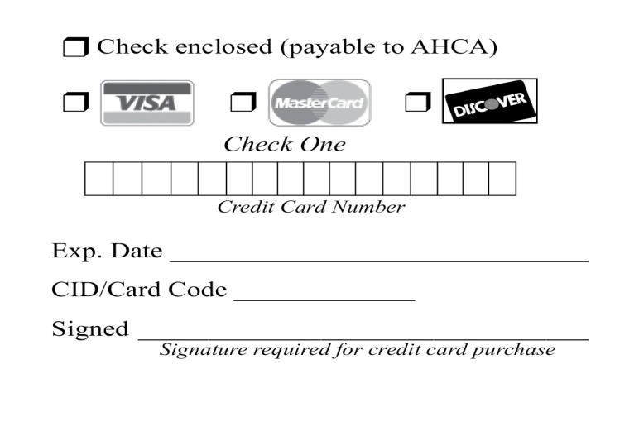

Advertising Schedule
Issue | Deadline | Publication
Winter | November 1 | January
Spring | February 1 | April
Summer | May 1 | July
Fall | August 1 | October

Please fill out the contract completely and send with payment to:
AHCA - Historic City Hall, 22 S. 4th Ave., Ste. 201, Brighton, CO 80601-2042

Breeder Advertising Space Rates
(Black and White)

Size | Single Issue | 4-Time Contract
Back Cover (7 ¾ x 6 ½ ) | $265 | $975
Inside Front Cover (7 ¾ x 10 ¼) | $265 | $975
Inside Back Cover (7 ¾ x 10 ¼) | $265 | $975
Premium Page (7 ¾ x 10 ¼) | $265 | $975
Full Page (7 ¾ x 10 ¼) | $225 | $830
2/3 Page (7 7/8 x 6 3/8) | $175 | $650
1/2 Page (7 7/8 x 5) | $140 | $520
1/3 Page (5 ¼ x 5) or (3 1/8 x 7 5/8) or (2 ½ x 7 5/8) | $100 | $375
1/6 Page (2 ½ x 5) or (5 x 2 ½) | $60 | $216
The 4-time rate is for four consecutive issues and must be prepaid before the first issue is printed
or AHCA will charge your credit card prior to each issue; receipt serves as notice.
These rates are for AHCA members. All others add 25%.

Color Rates (Additional)

4 – color process: $125 additional per issue.

Ad Setup and Change Rates (Additional)
- Ad setup: $150 for 2/3 or full page; $75 ½ page or less.
- Ad changes
Photo only: $40 for 2/3 or full page; $20 ½ page or less.
Text only: $40 for 2/3 or full page; $20 ½ page or less.

Closing Dates

All advertising copy (including photos) must be in this AHCA office by the 1st of the month preceding publication. (i.e., May 1 for June 1 publication). Although we devote the utmost care to the preparation of each advertising insertion, we cannot be responsible for errors made when copy is received after the deadline or by phone.

Terms

All advertising accounts are due and payable as invoiced. Interest charges of 1.5% per month (18% annual interest rate) will be assessed to accounts 30 days past due.

Advertising Content

The Bagpipe reserves the right to refuse any advertising or copy at its sole discretion. The Bagpipe assumes no responsibility for the accuracy of the advertising content as submitted. Advertisers assume all responsibility for the accuracy and truthfulness of submitted advertising containing pedigrees, statements regarding performance, etc.

Editorial Content

All rights reserved by The Bagpipe and the American Highland Cattle Association. No part of this publication may be transmitted or reproduced in any form, electronic or mechanical, without permission from the editor. Opinions expressed are those of the writer and not necessarily those of the American Highland Cattle Association. Photographs and manuscripts are welcome but no responsibility is assumed for such material while in transit or while in the editorial office.

INTERNET ADVERTISING CONTRACT AGREEMENT
EXHIBIT A

Description of Service Setup Fee Yearly Fee

Package A: One of two top right margin advertising spaces, $ 0.00 $500.00
Ad space “A”, size 200x200, Ad will display on the homepage
of AHCA website. Ad will randomly rotate with no more than three
different ads in the same space. (Total of six ads in two spaces)
CLIENT to provide complete advertising graphics in .jpeg format or AHCA
will design with approval of proof from the CLIENT. Ad rate is based
on CLIENT purchasing yearly “Bagpipe” advertising of one-third of page
or larger.

Package B: Middle bottom margin advertising spaces, $ 0.00 $500.00
Ad space “B”, size 728x90, Ad will display on the homepage
of AHCA website. Ad will randomly rotate with no more than three
different ads in the same space. CLIENT to provide complete advertising
graphics in .jpeg format or AHCA will design with approval of proof from
the CLIENT. Ad rate is based on CLIENT purchasing yearly “Bagpipe”
advertising of one-third of page or larger.

Package C: One of two lower right margin advertising spaces, $ 0.00 $375.00
Ad space “C”, size 200x200, Ad will display on the homepage
of AHCA website. Ad will randomly rotate with no more than three
different ads in the same space. (Total of six ads in two spaces)
CLIENT to provide complete advertising graphics in .jpeg format or AHCA
will design with approval of proof from the CLIENT. Ad rate is based
on CLIENT purchasing yearly “Bagpipe” advertising of one-sixth of page
or larger.

Web ads will run Jan 1-Dec 31 and be prorated if applicable.

The CLIENT agrees to pay for selected services to be provided by AHCA for the above fees, and abide by the above terms and conditions.

CLIENT Signature Title Date

